**fNIRS Protocol (Pilot):**

***The following is a draft Protocol for the fNIRS study as part of the MRes for David Collins.***

**Experiment 1 – Zoo Game Task (E-Prime)**

**TITLE: Functional Near-infrared Imaging of Cognitive Control**

**ABSTRACT:**

Functional near-infrared spectroscopy (fNIRS) is a non-invasive technique that measures hemodynamics in the surface of the brain. This study will employ fNIRS to capture measurements of brain functions in child and adult populations as they perform cognitive tasks. Specifically, a child-friendly Go/No-Go task will be used to test cognitive control, which involve overriding dominant or prepotent responses. The procedures will first be performed with university students, followed by testing of typically developing children. The measurements obtained will aim to characterise neural markers of cognitive events in normal-functioning children and adults that will provide a baseline for the further study of normal and abnormal development of cognitive processes.

**2. RESEARCH QUESTION / HYPOTHESIS**

The aim of this study is to conduct investigations using a relatively recent non-invasive imaging technique called functional near-infrared spectroscopy (fNIRS). The fNIRS system will be used to capture measurements of brain functions in child and adult populations as they perform cognitive tasks. Specifically, a child-friendly Go/No-Go task will be used to test cognitive control, which involves overriding dominant or prepotent responses. The procedures will first be performed with university student participants, followed by testing of typically developing children. The measurements obtained will aim to characterise neural markers of cognitive events in normal-functioning children and adults that will provide a baseline for the further study of normal and abnormal development of cognitive processes.

**3. MATERIALS AND METHOD**

**3.1 Participants**

There will be two participant groups covered by this study; one Adult group and one Child group. The Adult group will comprise young adults ranging from 18 to 25 years of age. This group will primarily be sourced from undergraduate students from Macquarie University undertaking Psychology and Cognitive Science studies and recruited via the SONA Systems pools as either paid or unpaid (credit points) research. If necessary, additional participants may supplement the group from alternate avenues such as printed adverts strategically around campus or by word of mouth.

The Child group will comprise typically developing 3-6 year old children. This group will predominantly be sourced via the established “Neuronauts” recruitment program used by other child studies conducted at Macquarie University. Advertisements may also be placed in magazines (e.g., Sydney’s Child) and online bulletin boards (e.g., GumTree), in addition to contacting participants who have taken part in previous studies and who have indicated a willingness for participation in future studies.

For both groups, an equal balance of males and females will be sought. As we are focused on healthy controls, participants should have no known history of neurological impairment (as per parent/self-report) or intellectual impairment (nonverbal IQ > 70). They will be screened for appropriateness as some may be ruled out due history of neurological problems (e.g. epilepsy), and any hearing problems or developmental problems that would prevent adequate participation in a set task. Exclusion criteria will be a personal or family history of autism, epilepsy, intellectual disability, or auditory sensory impairment. Participants will be advised they should not have any neuroactive medications a week before and at the time of participation. They also will be informed to try to have a good night sleep the night before, and refrain from drinking any caffeinated beverages 60 minutes prior to the testing session.

**3.2 Task**

Participants from both groups will perform the same modified version of a child-friendly Go/No-Go task based on the work originally conducted by McDermott and colleagues (2014). The task, called the “Zoo Game”, will consist of 75% Go trials and 25% No-go trials. This ratio ensures a prepotent desire to respond. Participants will be instructed to place equal emphasis on accuracy and speed on the Go/No-Go task.

The task will be presented using E-Prime 3.0 (Psychology Software Tools) on a 22-inch LCD monitor. The distance between the subject’s eyes and the screen will be approximately 50 cm. The researcher will be present in the testing room throughout the tasks to ensure task and behavioural compliance, providing feedback and encouragement between task blocks.

Participants are told they will play a game in which their goal is to help a zoo keeper. They are informed there are animals loose in the zoo and are asked to help “catch” them so they can be returned to their cages. However, there are three friendly orangutans helping the zoo keeper and thus should not be put back in their cages. This forms the basis of the Go/No-Go paradigm. Participants will be asked to press a button as quickly as they can each time the picture of an escaped animal is displayed (Go Trials) but to inhibit their response each time they see an orangutan (No-Go trials).

The practice block will be presented first to provide training on the task. This will consist of 12 trials comprising 9 zoo animals and 3 orangutans. Following completion of the trial, confirmation will be sought from the participant they understand and are comfortable with the task. Participants will then complete 8 blocks in total, each consisting of 40 trials (which will include 10 images of the orangutans and 30 novel zoo animal pictures) for a total of 320 individual trials. A fixation cross will be displayed preceding each animal image for a randomised interval ranging between 2000 and 5000 ms. The stimuli will be presented for 500 ms, followed by a blank screen for 500 ms (refer Figure 1). Responses could be made while the stimulus was on the screen or at any point during the following 500 ms. Each block consisted of novel sets of animal photographs, and each set will be balanced with respect to colour, animal type, and size. The timings for the fixation cross and animals being displayed may be modified if deemed necessary once initial piloting has been completed.

Reaction time (RT) and accuracy (ACC) are recorded. Performance feedback will automatically be provided on screen at the completion of each block of the task. This feedback will be based on calculated accuracy in the preceding block, with the aim to yield error rates of approximately 10% to ensuring an adequate number of trials. Participants will be also provided verbal performance feedback after each block of the Go/No-Go task if their accuracy was below 65% (“Remember to watch out for the orangutan friends”), or higher than 95% (“Remember to try and catch the animals even faster next time”). Before the beginning of the task and after blocks 2, 4, 6, 7, and 8, participants will be shown their current location on the Zoo Map (refer Figure 2).

**Triggers**

|  |  |
| --- | --- |
| **45** | PracticeReady onset - keyboard press |
| **55** | BlockIntro onset – keyboard press |
| **50** | Fixation cross onset * |
| **101** | Go image onset |
| **102** | NoGo image onset |
| **3** | during stimuli presentation (ie within 500ms of image being presented) |
| **7** | during response presentation (ie >500 ms from image being presented) |

* Fixation cross jittered (random 2-5 secs)

**3.3 Research Measures & Tools**

**3.3.1 Behavioural Measures**

Behavioural measures will include the number and percentage of error and correct trials for each subject as well as RTs. Participants could be correct on both Go trials by correctly responding to any animal that was not an orangutan and on No-go trials by correctly inhibiting a response when seeing an orangutan. Errors will be evaluated only for no-go trials, where participants commit errors of commission by responding. Participants with fewer than six error trials overall will not be included in the analyses. Average RTs on error and correct trials will be calculated separately. Trials with RTs that occurred after 1,000 ms will not be included.

Baseline measures of cognitive function may be recorded as behavioural data separate from the fNIRS data. This could include the Wechsler Abbreviated Scale of Intelligence (WASI-II) or Wechsler Adult Intelligence Scale to measure estimated IQ, the Standardised Mini-Mental State Examination (SMMSE) and/or the Montreal Cognitive Assessment (MoCA) test. These tests are designed to ensure the population tested falls within the healthy control population that this study is aimed at.

The Zoo Game task was developed to measure behaviour and ERPs associated with cognitive control processes. It is is suitable for use with children between 3-8 years of age, and has been used by researchers to examine the associations between cognitive control and children's anxiety, motivation, academic skills, and obesity in early childhood. However, to our knowledge it has not be used with fNIRS.

For the Children group, the parent or guardian will separately complete the demographic questionnaire.

**3.4 Procedure**

The assessment and investigation procedures will be conducted in the fNIRS Research Lab in the Cognitive Science Department at Macquarie University fNIRS, located on Level 3, The Australian Hearing Hub, 16 University Ave, Macquarie University, NSW 2109. After obtaining informed consent, participants will be fitted with an fNIRS cap containing several source and detectors probes. The sensors on the cap are connected by leads to a computer (NIRx) that will record brain activity whilst the participant is sitting in a resting state or performing the required tasks whilst in front of a computer monitor.

A typical recording session will involve the following steps:

(1) Participant is introduced to the lab environment and told what will be involved. If applicable, they will complete a questionnaire and be provided an opportunity to ask questions about the procedure.

(2) Subjects will be fitted with an appropriately sized fNIRS cap on their head by the researcher. The cap may have a number of source and detector points. These will measure brain energy levels as a way to determine activity of the brain in specific regions. We will need to make sure that there is a good connection between the scalp and the connector points in the cap, but there will be no need to use rubbing alcohol or conductive gel. Finally, we will check the cap connector connection, and if necessary, we will improve the connection by repositioning the electrode site. None of these procedures should be painful or uncomfortable. The participant can advise of discomfort at any stage, whereby we will adjust our procedure or stop the study.

(3) The participant will be introduced to the task, called the “Zoo Game” task. This will be presented on a computer screen in front of them. The researcher will provide clear instructions at this time on how to perform the task, which will require they press a button as quickly as possible when certain images of animals are presented on the screen. A practice session will allow familiarisation with the task.

(4) After the practice session, they will commence the Zoo Game task. The researcher will reconfirm the participant’s understanding of the instructions. The experiment will then commence, and the participants will view the screen and respond by pressing a button as demonstrated during the practice session. Brain activity will be recorded by a computer and later analysed by one of the researchers.

(5) After the session has been completed, the researcher will remove the fNIRS cap.

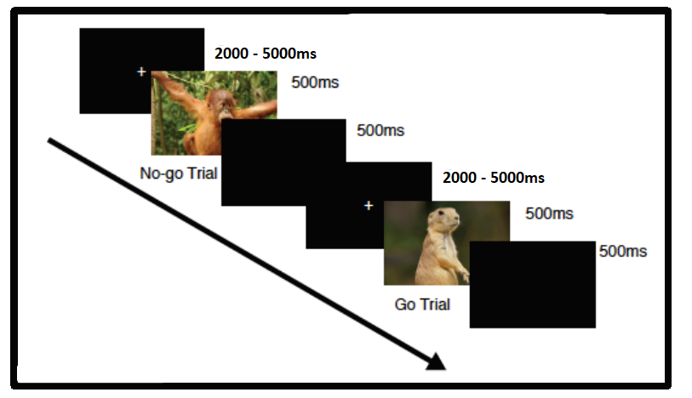

Figure 1 – Go/NoGo Zoo Game Task

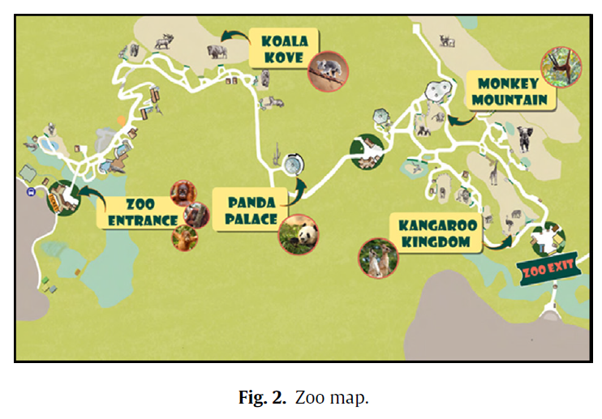

Figure 3 – FNIRS Montage showing Source, Detector and Channel location